**Housing Prices in Metropolitan Areas of India**

A House price prediction in a metropolitan city in India is a valuable solution for potential home buyers, real estate agents, and investors. By leveraging historical sales data, property details, and location-specific information, a predictive model can accurately estimate house prices. The model's scalability, real-time updates, user-friendly interface, and transparency ensure it meets the needs of stakeholders. Integration capability, data privacy, and cost-effectiveness are also important considerations. By addressing these requirements, the prediction model provides reliable insights, empowering stakeholders to make informed decisions in the fast-paced real estate market.

**INDEX:**

* TEAM DETAILS
* EMPATHY MAP
* BRAIN STORMING
* ANALYSIS OF DATA

**GROUP LEADER:**

S.TEJESHINI

**GROUP MEMBERS:**

N.THRISHA

S.VIDHYASRI

P.VIJALAKSHMI

K.BAGAVATHI

**EMPATHY MAP:**

An empathy map is a tool used in analysing housing price in etero politan areas of India

It has 4 quadrants

|  |  |  |
| --- | --- | --- |
| **City** | **Average Price Q2 2023(₹/sq ft)** | **Y-o-Y Change** |
| Chennai | 7,653 | 3% |
| Delhi NCR | 8,652 | 3% |
| Hyderabad | 10,530 | 1% |

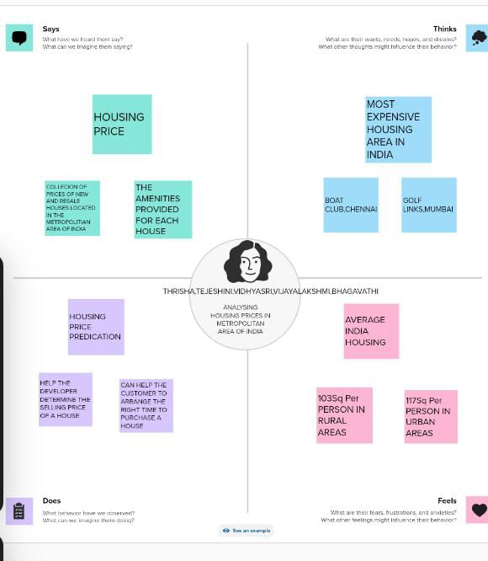

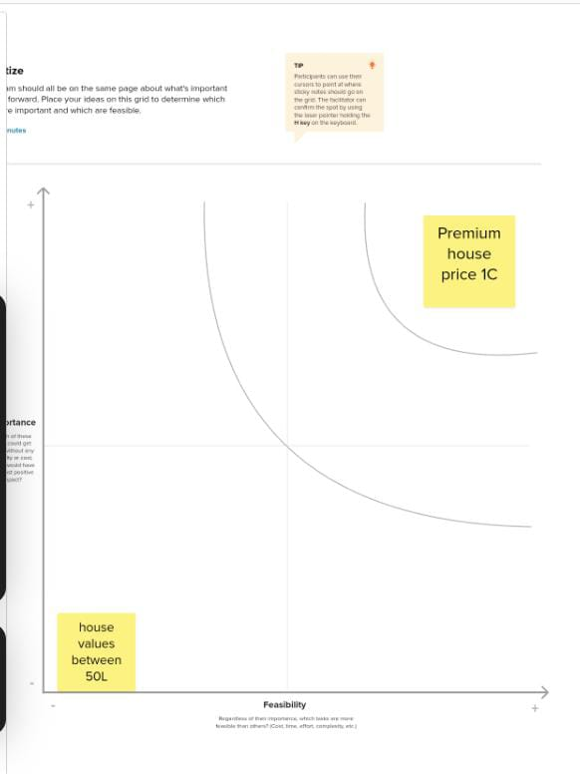

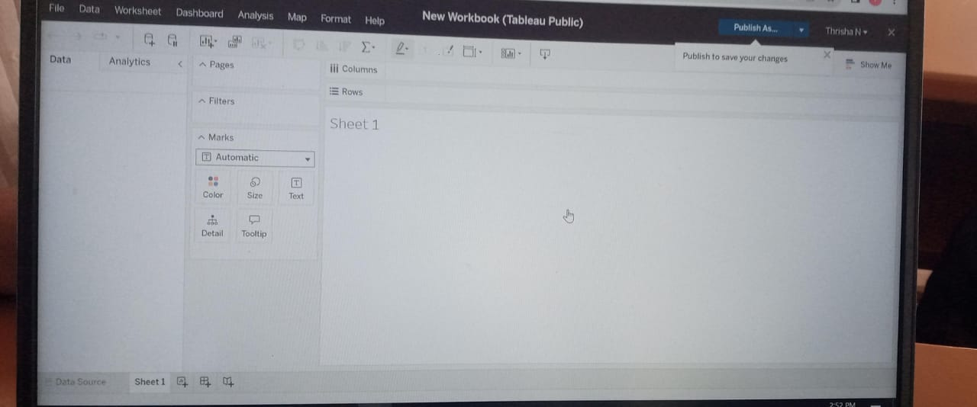

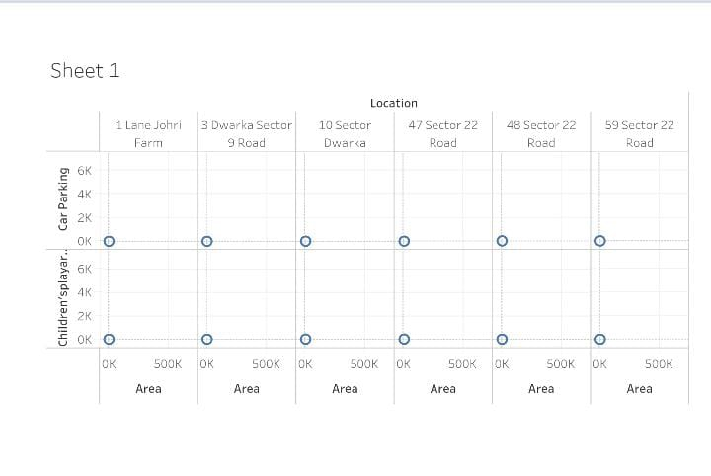

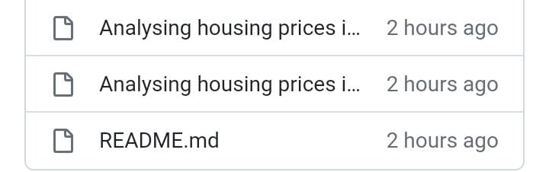

**CONCLUSION**

According to recent data from the National Housing Bank (NHB), housing prices have seen a steady increase in various cities in India. In the first quarter of 2022-23, housing prices rose in 42 cities, while rates of residential units fell in five cities and remained stable in three cities.

**THANK YOU**